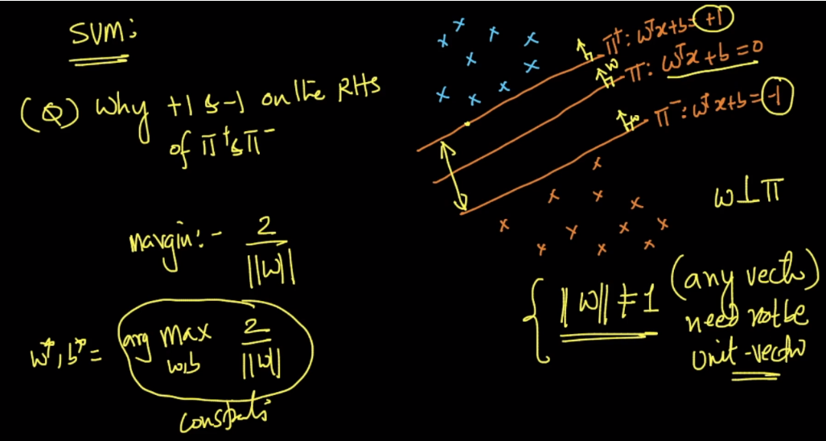

Why do we take value +1 and -1 for pie+ and pie-.

**1st intuition:**

Let’s say we pick k in place of 1. Here k would be any constant, 4, 8 or anyting.

Now margin distance will be 2*k / ||W||.

In this case also the w where we get max of new margin distance will be similar to w where we get max of old margin dist.

**2nd intuition:**

Since w is not a unit vector, so we can divide the k on both side of equation and get new w and b with value = 1.

